Project Development Phase
Model Performance Test

Date | 30 September 2026
Team ID | MKU201Team66ab4dee00fc666a751b56cd7
Project Name | Script-Controlled ACL – Restrict Record Access Based on Field Value
Maximum Marks | 10 Marks

Model Performance Testing:
Project team shall fill the following information in model performance testing template.
S.No. | Parameter | Values | Screenshot
 | Metrics | Regression Model:  Not applicable – no regression model is used in this project.  Classification Model:  Not applicable – no ML classification model. Access decisions are rule-based (Allow / Deny): Admin → all records; bb1 user → only EEE records; user without role → no records. | 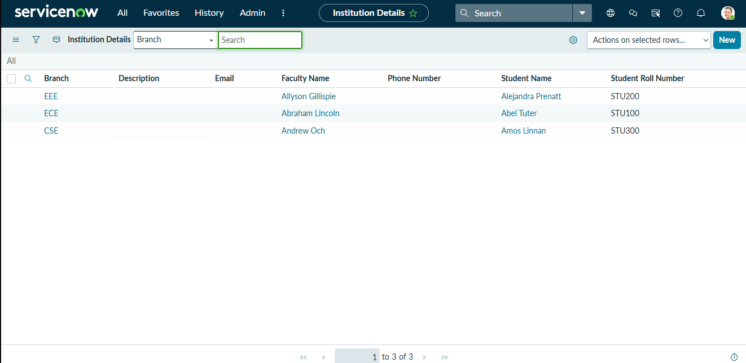
 | Tune the Model | Hyperparameter Tuning - Not applicable. Read ACL refined with role bb1, data condition “Branch is EEE” and script.  Validation Method - Impersonation testing (EEE User, user without role, Admin). | 